**ST.XAVIER’S COLLEGE**

MAITIGHAR, KATHMANDU



Computer Graphics

Assignment #7

Submitted By:

Aabhash Dhakal

013BSCCSIT001

2nd year/ 4th semester

Submitted to:

|  |  |
| --- | --- |
| Er. Anil K. Sah  Lecturer  Department of Computer Science |  |

**STATEMENT**

Write a program to translate, rotate and scale the following image.

­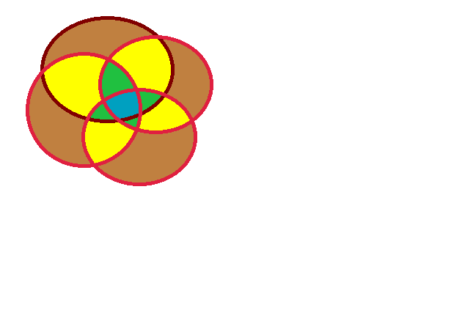

**SOURCE CODE**

//---------------------------------------------------------------------------

#include <vcl\vcl.h>

#pragma hdrstop

#include "tr.h"

#include "math.h"

//---------------------------------------------------------------------------

#pragma resource "*.dfm"

TForm1 *Form1;

int tx,ty,r,sx,sy;

int i,j;

int x,y;

int a,b;

//---------------------------------------------------------------------------

__fastcall TForm1::TForm1(TComponent* Owner)

: TForm(Owner)

{

}

//---------------------------------------------------------------------------

void __fastcall TForm1::Edit1Change(TObject *Sender)

{

tx = Edit1->Text.ToInt();

}

//---------------------------------------------------------------------------

void __fastcall TForm1::Edit2Change(TObject *Sender)

{

ty = Edit2->Text.ToInt();

}

//---------------------------------------------------------------------------

void __fastcall TForm1::Edit3Change(TObject *Sender)

{

r = Edit3->Text.ToInt();

}

//---------------------------------------------------------------------------

void __fastcall TForm1::Edit4Change(TObject *Sender)

{

sx = Edit4->Text.ToInt();

}

//---------------------------------------------------------------------------

void __fastcall TForm1::Edit5Change(TObject *Sender)

{

sy = Edit5->Text.ToInt();

}

//---------------------------------------------------------------------------

void __fastcall TForm1::Button1Click(TObject *Sender)

{

x = Image1->Width;

y= Image1->Height;

for( i = 0; i <= x; i++)

{

for(j = 0; j <= y; j++)

{

a = i + tx;

b = j + ty;

Image2->Canvas->Pixels[a][b] = Image1->Canvas->Pixels[i][j];

}

}

}

//---------------------------------------------------------------------------

void __fastcall TForm1::Button3Click(TObject *Sender)

{

x = Image1->Height;

y = Image1->Width;

for(i=0;i<=x;i++)

{

for(j=0;j<=y;j++)

{

a = i * sx;

b = j * sy;

Image2->Canvas->Pixels[a][b] = Image1->Canvas->Pixels[i][j];

}

}

}

//---------------------------------------------------------------------------

void __fastcall TForm1::Button2Click(TObject *Sender)

{

x = Image1->Height;

y = Image1->Width;

for(i=0;i<=x;i++)

{

for(j=0;j<=y;j++)

{

a = i*cos(r)-j*sin(r);

b = j*cos(r)+i*sin(r);

Image2->Canvas->Pixels[a][b] = Image1->Canvas->Pixels[i][j];

}

}

}

//---------------------------------------------------------------------------

**OUTPUT SCREEN**

Translation

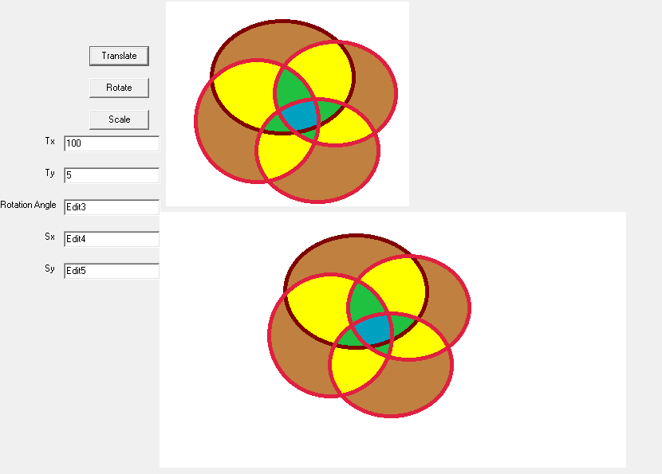

Rotation

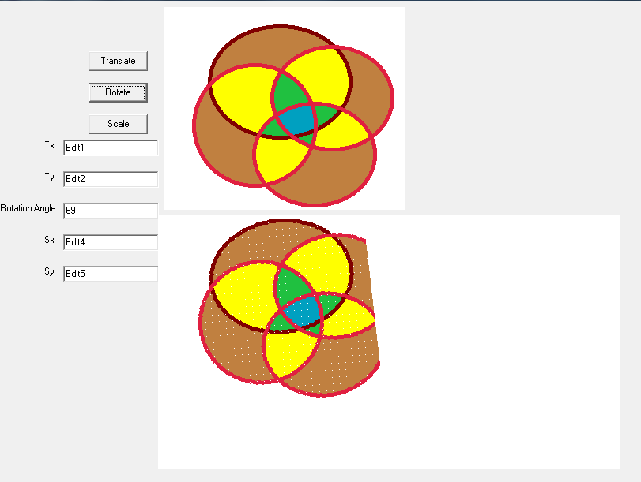

Scaling

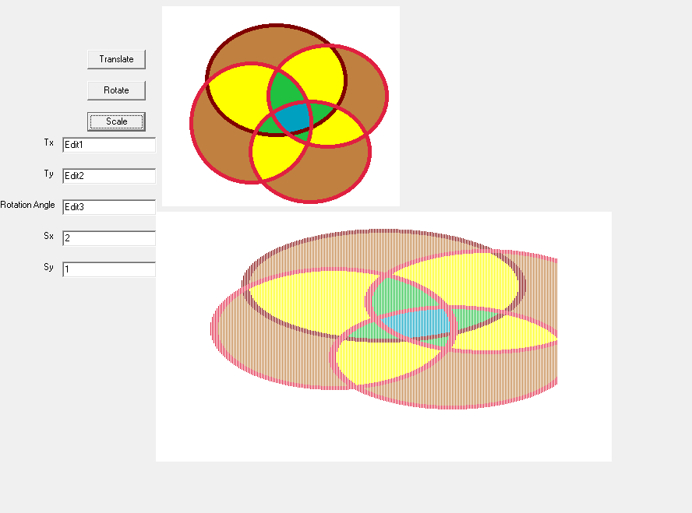

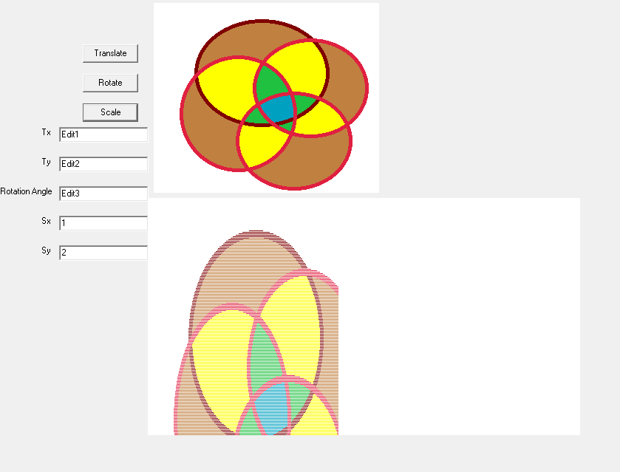

**CONCLUSION**

Hence, the given image was translated, rotated and scaled using C++ builder.